

**WEB DESIGN AND CLIENT SIDE SCRIPTING**

**EUGENE MCLAUGHLIN**

**HDCSDEV_INT** - **HIGHER DIPLOMA IN SCIENCE IN COMPUTING**

**Go Training Fitness Centre**

**Project Report**

**Students**:

Guilherme Silveira – Student Number 23413271

Clara Freitas da Silva – Student Number 23425083

Alexandre Duarte da Rocha – XXX

INDEX

1. Project Summary 2

2. Design Process 3

2.1. Research & Investigation 3

2.2. Requirements & Technical Approach 5

2.3. Design & Wireframe 6

2.3.1. UI Kit Design 6

2.3.2. Wireframes 7

3. Project Work 12

Breakdown of Tasks 12

4. Development 12

4.1. Bootstrap Integration 12

4.2. JavaScript Implementation 14

4.2. Validation 16

4.3. SEO and Optimization 19

4.5. Testing 21

4.5.1. Responsiveness 21

5.Website Deployment 27

6. Results and Achievements 27

7. Teamwork and Improvements 27

8. Conclusion 27

8. References 28

# 1. Project Summary

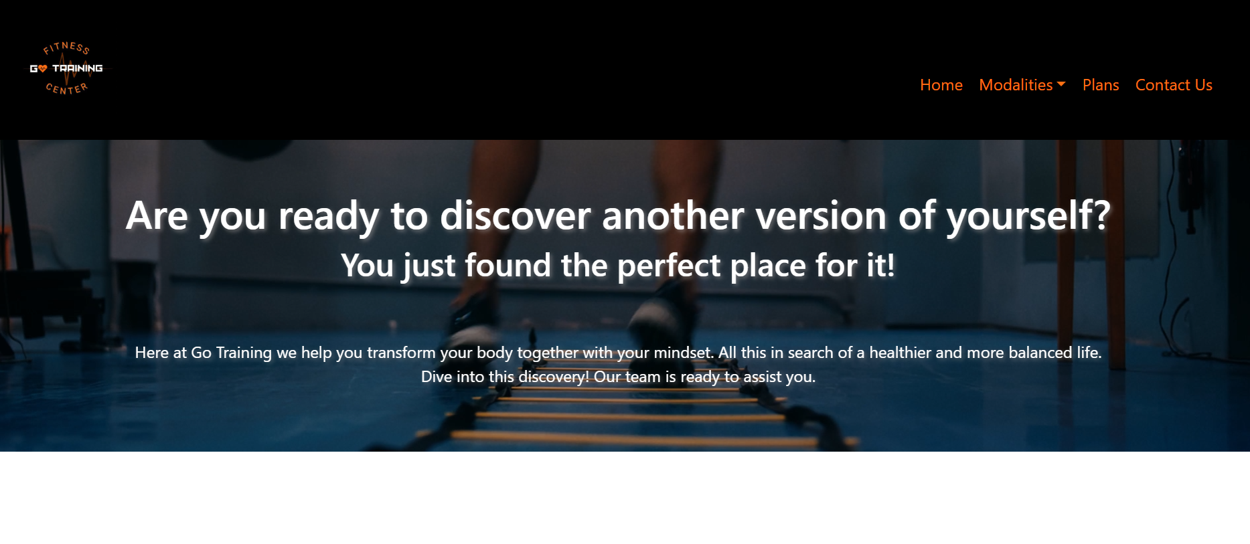

The “Go Training Fitness Centre Website” was developed to deliver a modern, responsive, and visually captivating platform that showcases the fitness centre’s services. The primary purpose was to highlight various offerings, including some training modalities such as CrossFit and Swimming, membership plans, and contact information, while ensuring accessibility across different devices.

The presented project had a strong emphasis of having a clean and easy understanding design with intuitive navigation. With the integration of modern web tools such as HTML, CSS, Bootstrap, and JavaScript, we were able to fulfill the points mentioned, and assure responsiveness. These technologies enabled the creation of a user-friendly experience that meets industry standards and user expectations by making the platform more functional and pleasing to the eyes of those who access it and at the same time capturing the user's attention to its content.

# 2. Design Process

## 2.1. Research & Investigation

To understand user expectations and industry standards, we analyzed several fitness websites, such as SmartFit, Bodytech, Stoneybatter Cross Training and Competition Gym, which provided inspiration for layout, color schemes, and content presentation. Key insights included the importance of high-quality visuals, clear navigation, and the effective presentation of membership options. This research informed the structure and design of the “Go Training” website.

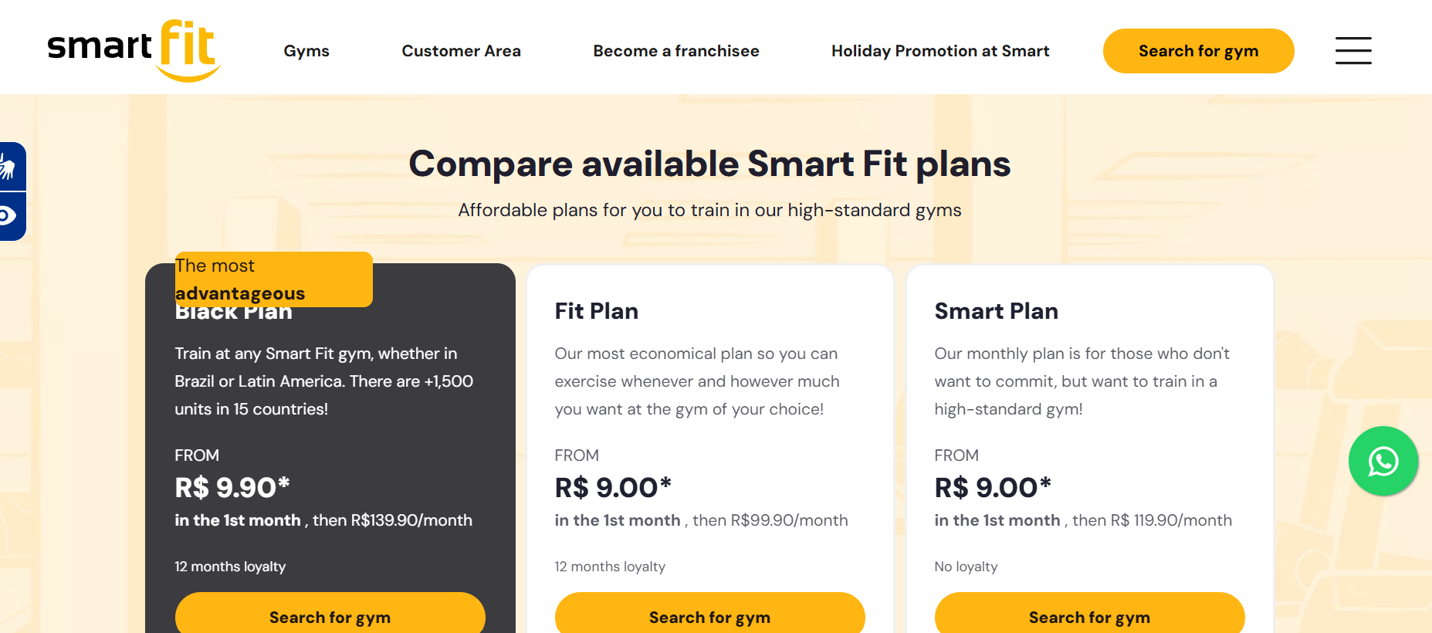

Fig.1 Smart Fit. (n.d.). Plans. Retrieved November 27, 2024. From <https://www.smartfit.com.br/>

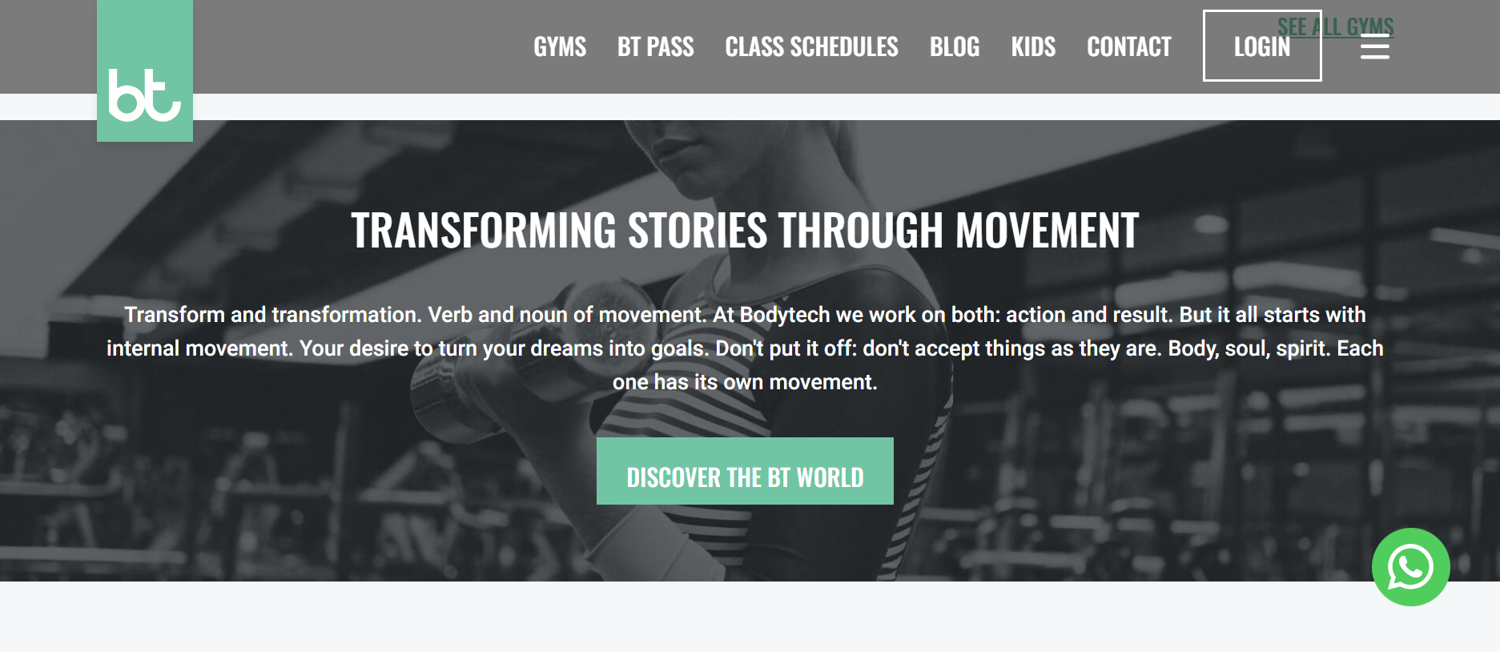

Fig.2 Bodytech. (n.d.). Home. Retrieved November 27, 2024. From <https://www.bodytech.com.br/>

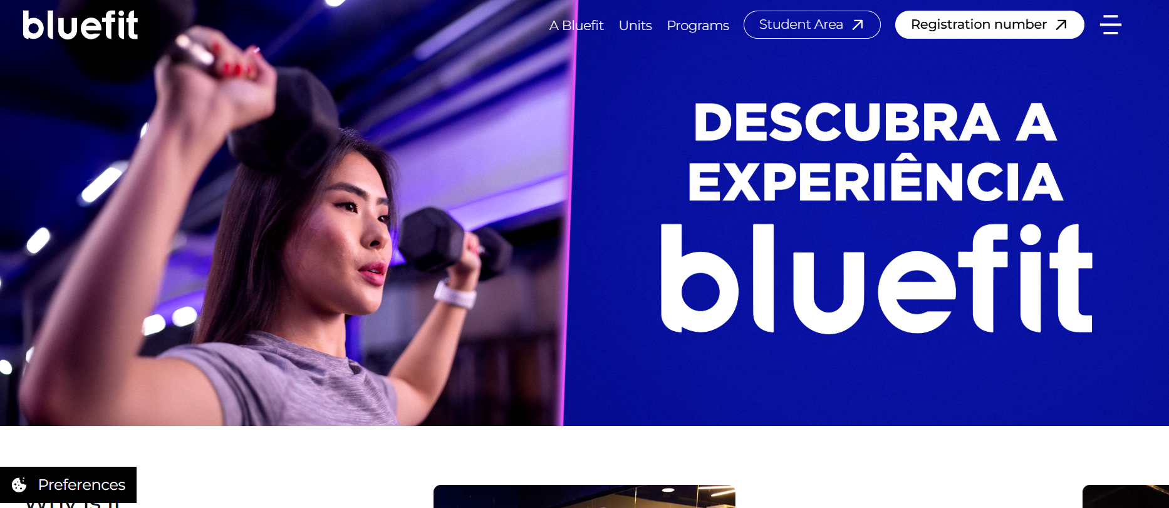

Fig.3 BlueFit. (n.d.). Home. Retrieved November 27, 2024. From <https://www.bluefit.com.br>

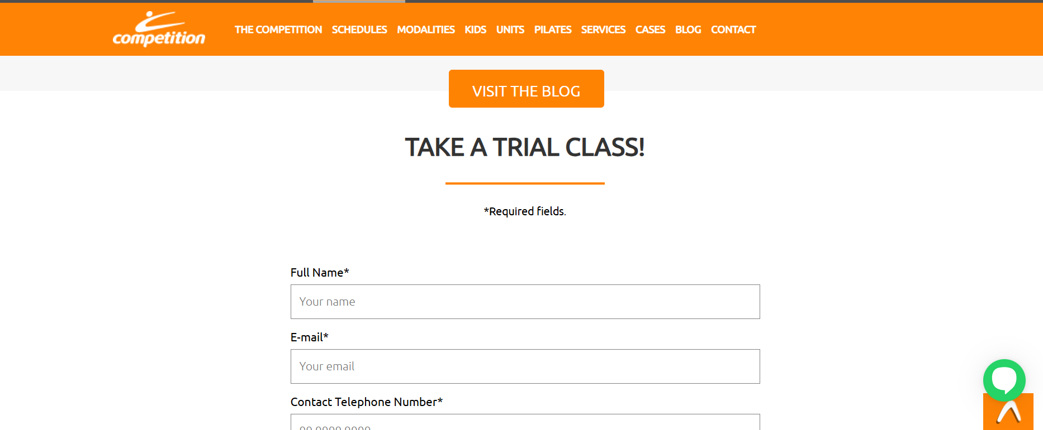

Fig.4 Competition Gym.( n.d.). Home. Retrieved November 27, 2024. From <https://www.competition.com.br>

## 2.2. Requirements & Technical Approach

The project aimed to create a responsive website with six pages: **Index**, **Swimming**, **Contact Us**, **Open Gym**, **Plans**, and **CrossFit**. Each page needed to have a clean design, easy navigation, and a consistent style that matched the fitness theme.

To build the website, the team used **HTML**, **CSS**, **JavaScript**, and **Bootstrap**:

* **HTML** was used to structure the content on each page.
* **CSS** helped style the pages with colors, fonts, and layouts to make the website look clean and modern.
* **JavaScript** added interactive features like carousels, on click button and form validation to make the website more dynamic and user-friendly.
* **Bootstrap** made the site responsive, so it works well on different screen sizes, like phones, tablets, and desktops.

The team used **GitHub** for version control and collaboration, which made it easy to track changes and combine everyone’s work. Development was done in **VS Code**, a simple yet powerful tool for writing and debugging code.

The technical approach focused on using reliable tools and keeping things simple while ensuring the website was functional, visually appealing, and easy for users to explore.

## 2.3. Design & Wireframe

## 2.3.1. UI Kit Design

The website uses a color palette of black, white, gray, and orange to balance sobriety with visual appeal. Fonts and buttons were selected for readability and user engagement. The Go Training logo, designed with a heart and heartbeats symbolizing vitality, reinforces the website’s theme of health and wellness.

Student Clara used Canva application to create a UI kit to be used in the development of this project, containing colour palette scheme, font families, logo, navigation bar and footer designs. This kit information will be applied across all project pages.

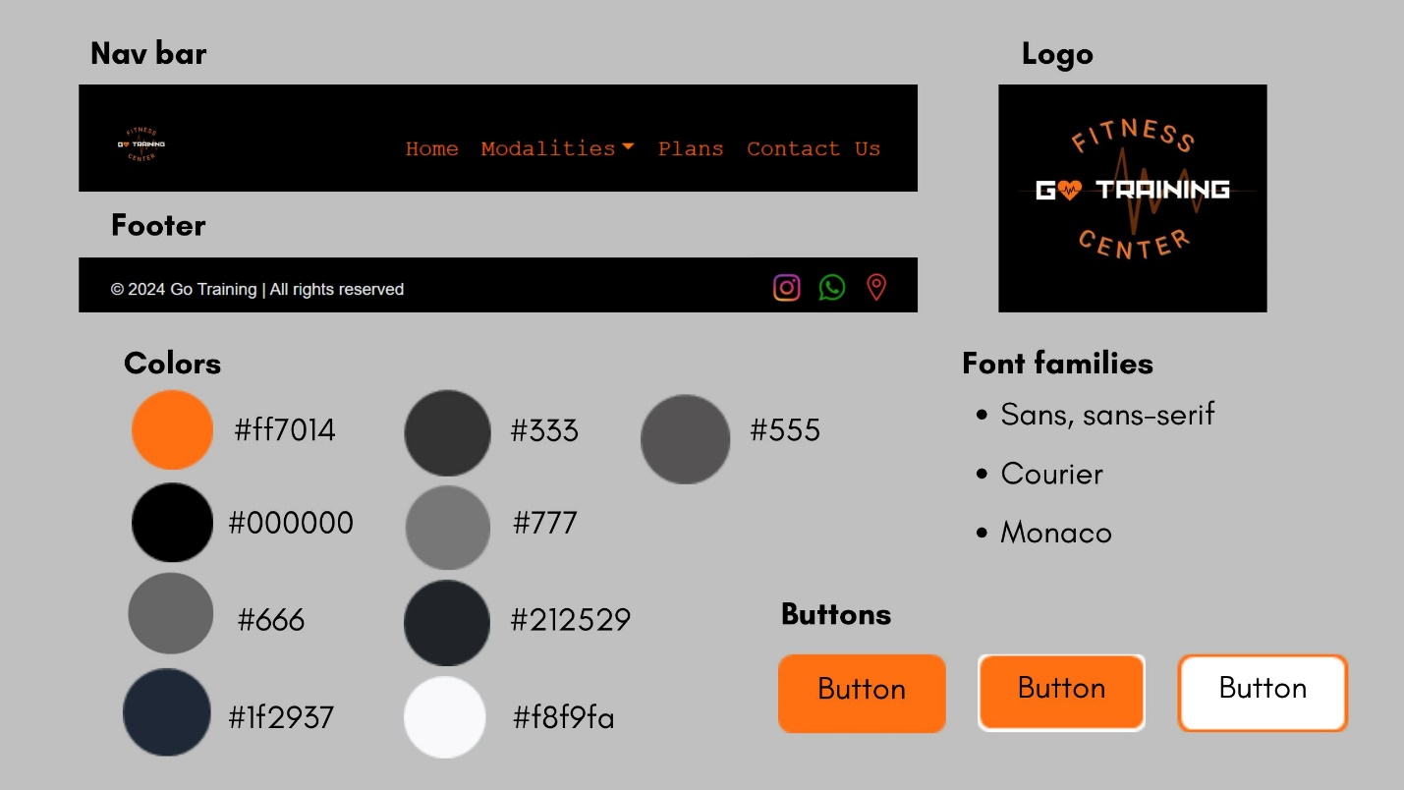

Fig.5. UI Kit created by student Clara

## 2.3.2. Wireframes

Wireframes were created for each page making use of the draw.io website.

|  |  |  |
| --- | --- | --- |
| **Student** | **Page** | **Wireframe** |
| Clara | Index |  |
| Swimming |  |

|  |  |  |
| --- | --- | --- |
| Guilherme | Plans |  |
| Crossfit |  |

|  |  |  |
| --- | --- | --- |
| Alexandre | Contact Us |  |
| Open Gym |  |

# 3. Project Work

## Breakdown of Tasks

The project was divided among the team members in the following way:

**Clara**

* Worked on the **Index** and **Swimming** pages.
* Created the **Go Training logo**, designed the **UI Kit** and **navigation bar** for all pages,showing the current path active, and making sure these features had a clean and appealing look that matched the theme of the website.

**Guilherme**

* Handled the **Plans** and **CrossFit** pages.
* Implemented the **floating button**, which allows the users to switch the styles of the modality pages, added interactive features like **carousels** and designed the **footer** for all pages.

**Alexandre**

* Focused on the **Contact Us** and **Gym** pages.
* Built the **contact form** and added **form validation** to make sure it worked smoothly.

The team used **GitHub** to track tasks, share updates, and keep everything organized. This made sure everyone’s work fit together without any problems.

# 4. Development

## 4.1. Bootstrap Integration

Bootstrap was a big help in making the website look modern and responsive. It allowed us to quickly set up layouts using its grid system, which automatically adjusted to fit different screen sizes. This made it easy to design pages without starting from scratch for each device.

The navigation bar was made using Bootstrap tools, making it interactive with dropdown menus and a responsive design. Buttons and other elements were styled with Bootstrap classes, which saved time and gave a clean, professional appearance.

Overall, Bootstrap simplified a lot of the work and kept everything consistent across the website.

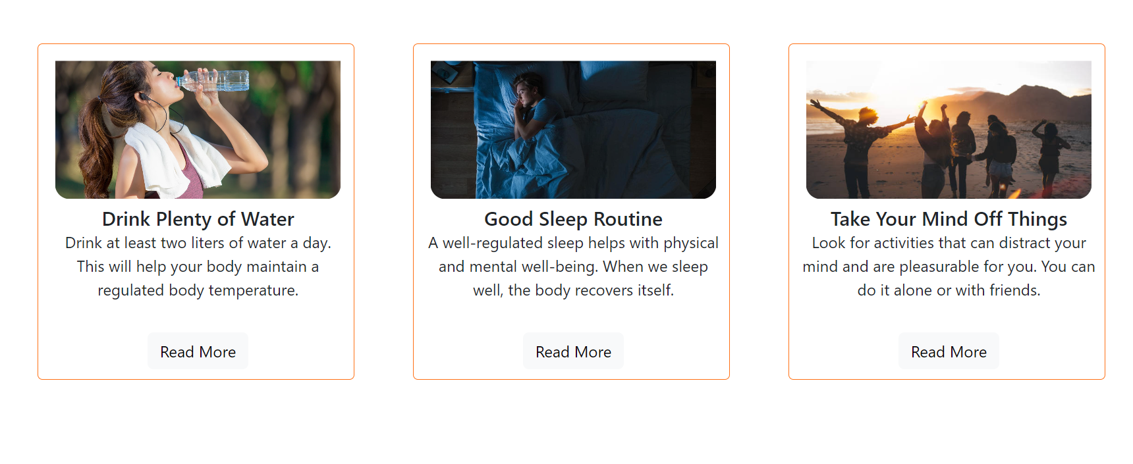

Fig. 5. Tips section using HTML, CSS and Bootstraps Card component (created by Student Clara)

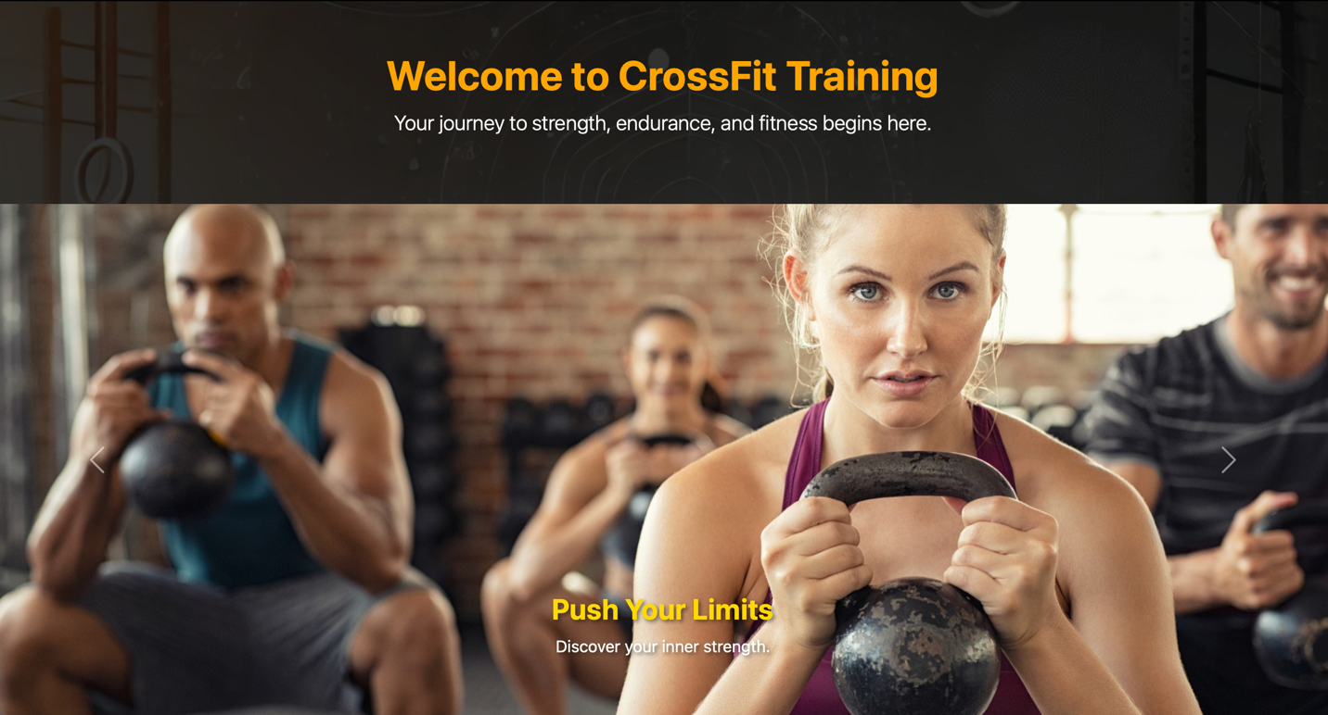

Fig. 6. Display of images created using HTML, CSS and Bootstraps Carousel component (created by Student Guilherme)

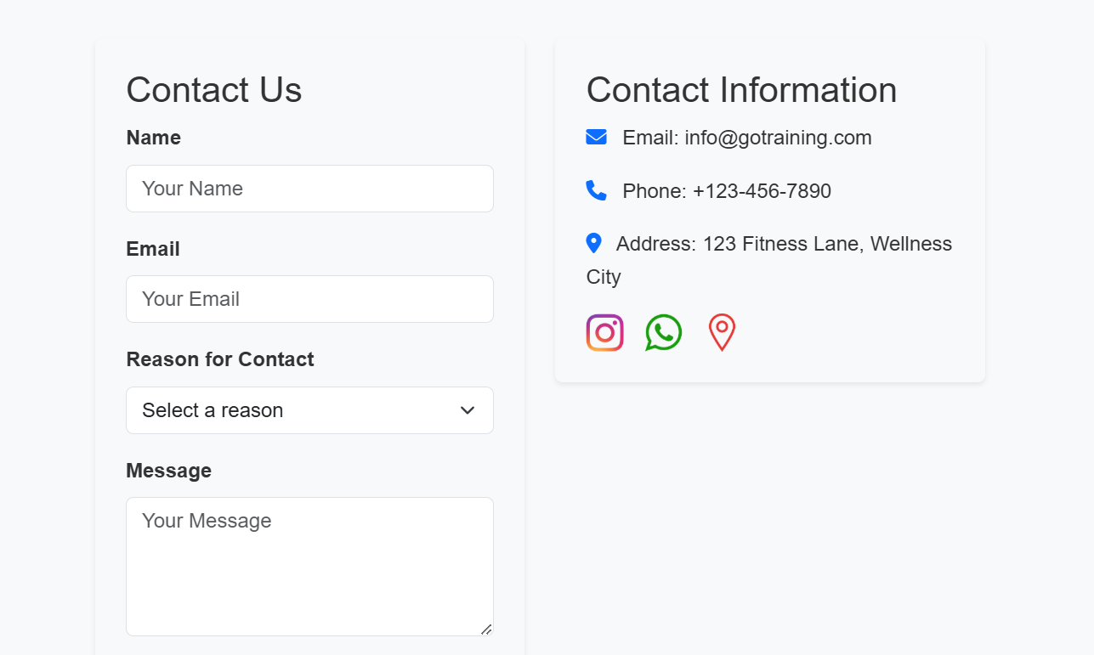

Fig. 7. Forms section created using HTML, CSS and JavaScript to validate (created by Student Alexandre)

## 4.2. JavaScript Implementation

To enhance user interactivity and provide a unique feature on the CrossFit page, a **floating button** was implemented by the student Guilherme to allow the users to toggle between two stylesheets: the external.css and the student’s individual stylesheet. This button is fixed at the top-right corner of the screen and remains accessible even when the user scrolls down the page.

**How it was implemented**

1. **HTML Integration:** A button element was added with the ID toggleStyles and assigned to the class floating-button to enable custom styling.



1. **CSS for Floating Button:** Using CSS, the button was styled to stay fixed in the top-right corner of the screen. The <position: fixed> property ensures it remains in place during scrolling.

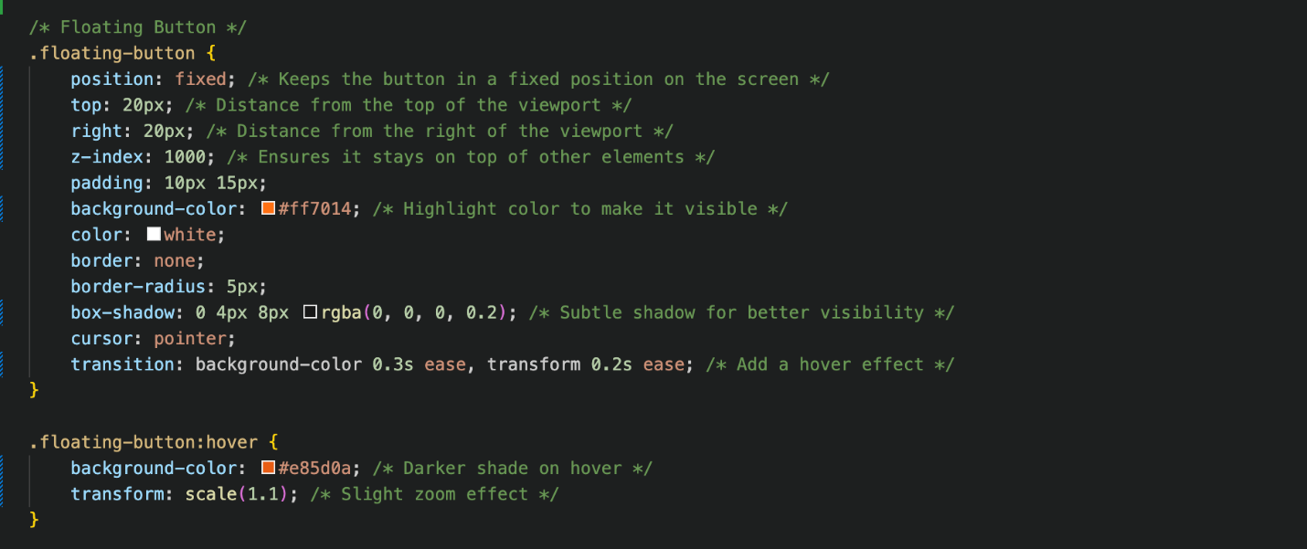

1. **JavaScript Functionality:** A simple JavaScript function was written to toggle the <href> attribute of the link element responsible for loading the CSS file. This switches the stylesheet whenever the button is clicked.

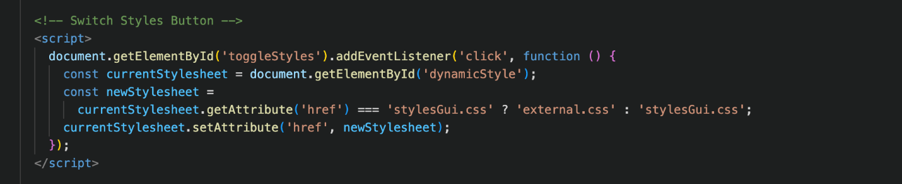

To make it clear to the user what page the person is currently at the website, it was implemented a JavaScript element which returns a visual mark on the nav bar link.

**How it was implemented**

1. **CSS for active path:** Using CSS, the active path was styled to be highlighted in a different color on the nav bar, so that you can visually see whatever page you are on the website.

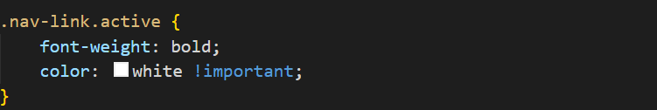

1. **JavaScript Functionality:** A simple JavaScript code was written to select the nav bar and dropdown items links and return the active link at the moment.

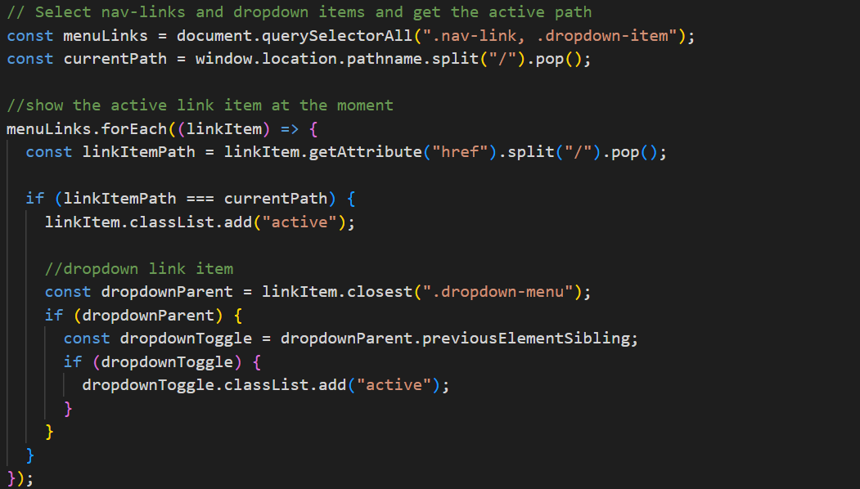

This line imports Bootstrap 5.3.0, a front-end library providing pre-built components and JavaScript-based features.  
As it is used to add scroll-based animations to HTML elements, student Alexandre decided to take this tool to implement a sophisticate effect in my contact page.

This imports AOS v2.3.4, a library used for adding scroll-based animations to HTML elements.

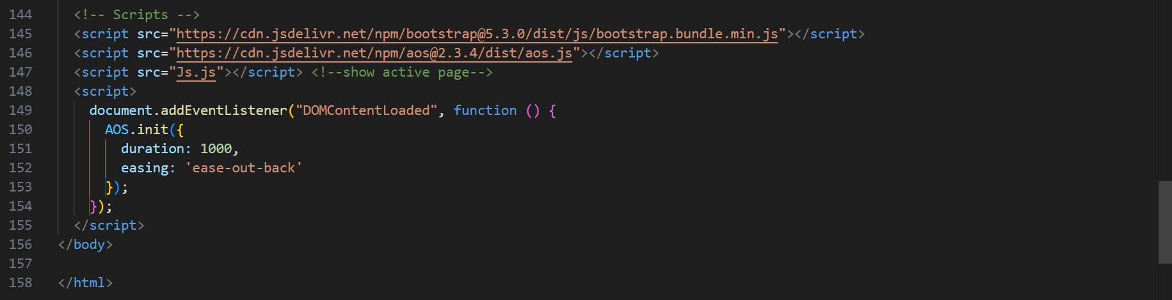To ensure that the script runs only after the HTML content has fully loaded, and to configurate the AOS Library mentioned above, these commands were used:

Concluding with a gradual appearance effect of the content through a beautiful mouse scroll effect.

## 4.2. Validation

HTML and CSS were validated using W3C tools to ensure standards compliance.

**Plans and Crossfit - Guilherme**

To fix errors on the CrossFit and Plans pages and make them follow HTML5 standards, it was necessary to remove extra slashes from <meta> and <img> tags, add headings to sections that didn’t have them, quote all attribute values properly and adjust heading levels. These fixes helped make the pages more organized and user-friendly.

|  |
| --- |
| **Plans Page** |
| Before Adjustments |
|  |
| After Adjustments |
|  |

|  |
| --- |
| **Crossfit Page** |
| Before Adjustments |
|  |
| After Adjustments |
|  |

The css file made by Guilherme (stylesGui.css) did not show any errors.

|  |
| --- |
| stylesGui.css - Crossfit Page |
|  |

**Index and Swimming – Clara**

To make Index and Swimming Pages follow HTML5 standards, it was necessary to remove slashes from <img> tags which did not have any effect on void elements and interacted badly with unquoted attributes and also remove the end tag “/” from </br> so that both pages will be organized and written following the standards.

|  |
| --- |
| **Index Page** |
| Before Adjustments |
|  |
| After Adjustments |
|  |

|  |
| --- |
| **Swimming Page** |
| Before Adjustments |
|  |
| After Adjustments |
|  |

The extra and personalized CSS file to be applied to one of student Clara’s page did not return any error or information message.

|  |
| --- |
| **stylesClara.css - Swimming Page** |
|  |

**Contact Us and Open Gym – Alexandre**

|  |
| --- |
| **Contact Us Page – No errors** |
|  |

|  |
| --- |
| **Gym Page, Before -** |
|  |

|  |
| --- |
| **Gym Page after – No errors** |
|  |

It was necessary to remove spaces in the images names, and remove strange scripts in the meta lines.

|  |
| --- |
| **styleAlex.css - No errors** |
|  |

## 4.3. SEO and Optimization

Images were optimized for fast loading using Tinify and Optimizilla. It resulted in a considerable reduction size of the images as shown in the screenshots below.

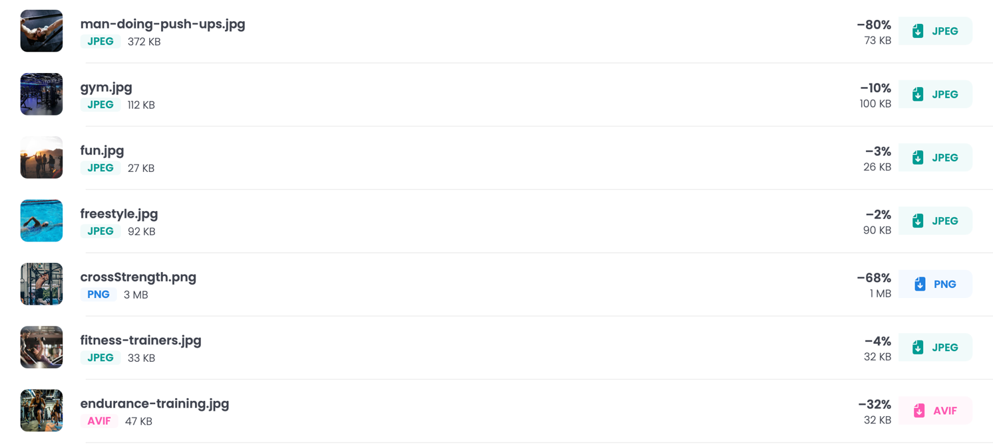

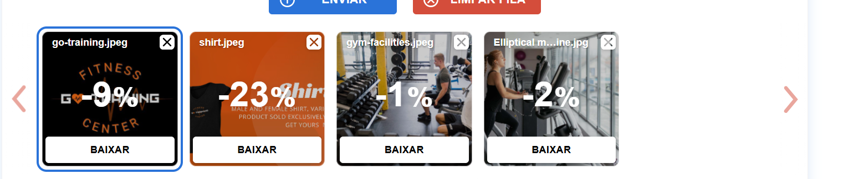

Proper use of alt attributes was made to improve accessibility (e.g., Crossfit Page created by Guilherme, Swimming Page created by Clara and Gym Page created by Alexandre as shown below).

- CrossFit Page created by student Guilherme

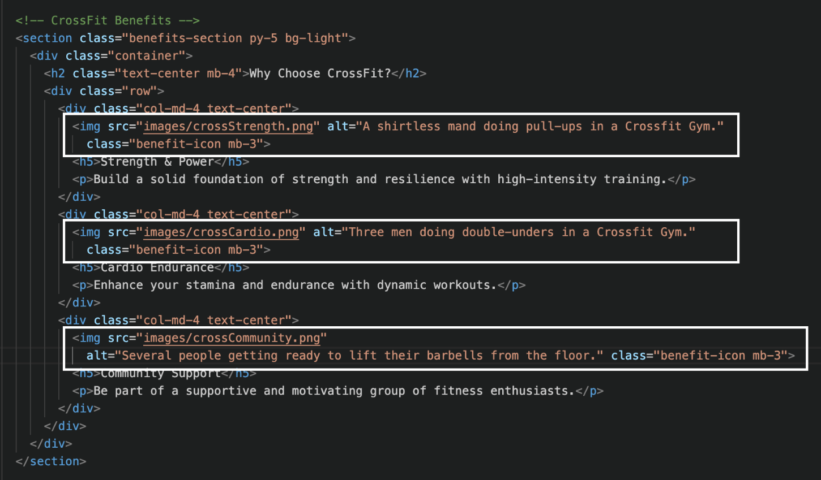

- Swimming Page created by student Clara

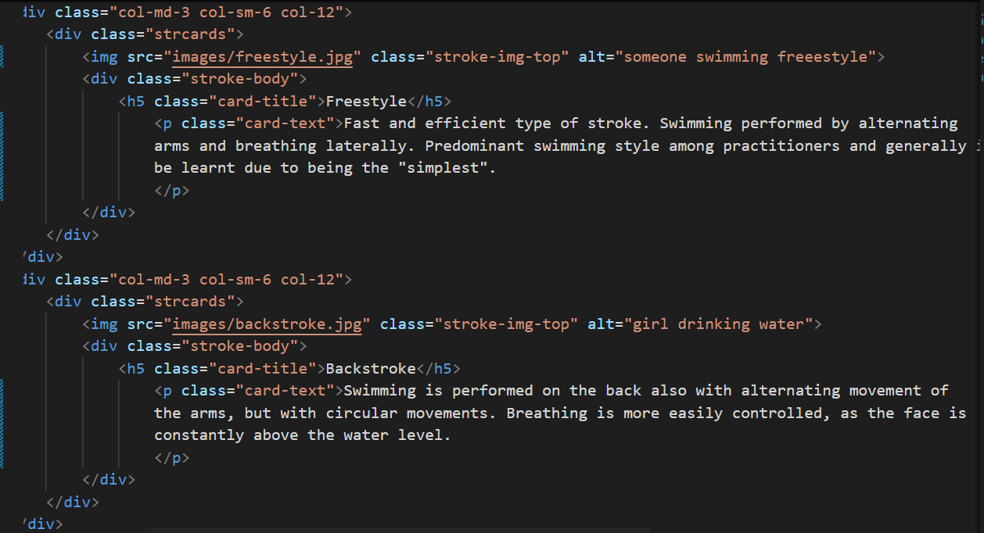

- Gym Page created by student Alexandre

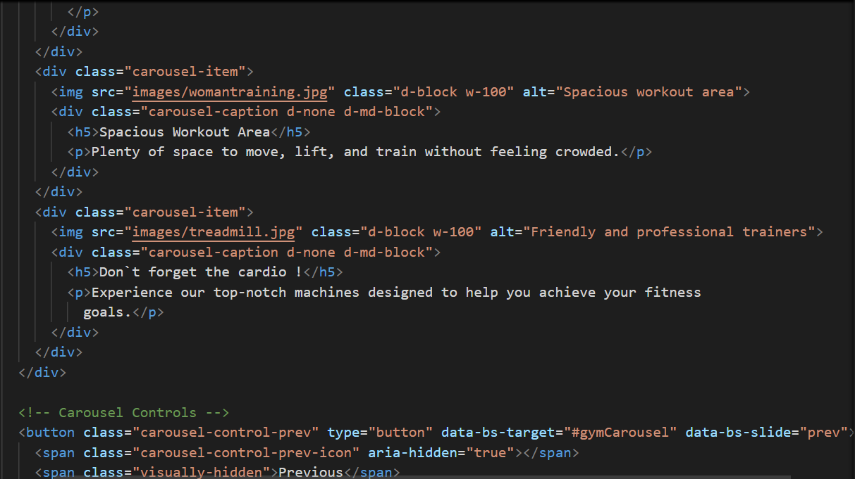

## 4.5. Testing

## 4.5.1. Responsiveness

We used Bootstrap extensively in our project to ensure responsiveness and a consistent layout across various screen sizes. Bootstrap’s grid system, with classes like col-lg, col-md, and col-sm, helped us create flexible layouts that automatically adjust based on the viewport size.

In addition to Bootstrap, we implemented custom CSS media queries to handle specific styling needs that were not covered by default Bootstrap classes. These media queries allowed us to fine-tune the appearance of elements like font sizes, paddings, and margins for different screen widths.

Together, Bootstrap and CSS media queries ensured that our website provides a seamless and visually appealing experience across devices.

**Plans and Crossfit Pages (Guilherme)**

In the Plans and CrossFit pages, the Bootstrap grid allowed content, such as plan cards and carousels, to rearrange from multi-column layouts on large screens to single-column layouts on smaller devices (e.g., cards in Plans Page).

|  |  |
| --- | --- |
| **Plans Page - Cards** | |
|  | |
| **col-lg-4** | |
|  | |
| **Col-md-6** | **Col-sm-12** |
|  |  |

CSS media queries adjusted the size of the plan cards and centered buttons on smaller screens to maintain usability and aesthetic consistency (e.g., “Choose a Plan” button).

|  |
| --- |
| **Plan Page – “Choose a Plan” Button** |
|  |
| **Large Screen (width > 991px)** |
|  |
| **Smaller Screen (width <= 991px)** |
|  |

**Index and Swimming Pages (Clara)**

In the Index and Swimming pages, the Bootstrap grid allowed content, such as plan cards and carousels, to rearrange from multi-column layouts on large screens to single-column layouts on smaller devices (e.g. Tips Section on Index Page).

|  |
| --- |
| **Index Page – Tips Section (card content)** |
|  |
| **col-lg-4** |
|  |

|  |  |
| --- | --- |
| **Col-md-6** | **Col-sm-12** |
|  |  |

CSS media queries adjusted the size of the plan cards and centered textual content and photos (e.g. What we offer section on Index page).

|  |
| --- |
| **Plan Page – “Choose a Plan” Button** |
|  |

|  |
| --- |
| **Large and Medium Screen (width > 768px)** |
|  |
| **Smaller Screen (width <= 768px)** |
|  |

**Contact Us and Open Gym Pages (Alexandre)**

In the Contact Us page the Responsiveness starts in the Navbar:



Which ensures that it collapses into a hamburger menu on smaller screens (typically for devices under 992px wide). And it includes a brand logo and a set of navigation links, which switch to a collapsible dropdown on smaller screens.

This is important because it ensures that the navigation remains user-friendly and accessible on both desktop and mobile devices.

**Top Image**:

The top image is set as a full-width image (w-100) with the img-fluid class, which makes it responsive. It ensures that the image scales appropriately on various screen sizes without overflowing the container.  
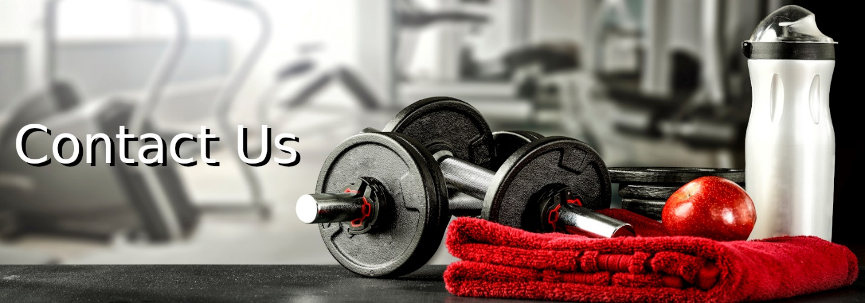  
**Contact Form and Contact Information**:

Both the form and the contact information are placed in a row with Bootstrap’s grid system, which adjusts according to screen size. On larger screens (lg and above), the form and the contact info are placed side-by-side in col-lg-6 columns.

On smaller screens, the columns will stack vertically, ensuring readability and usability. This is handled by Bootstrap’s responsive grid, which automatically adjusts column widths based on the screen size:

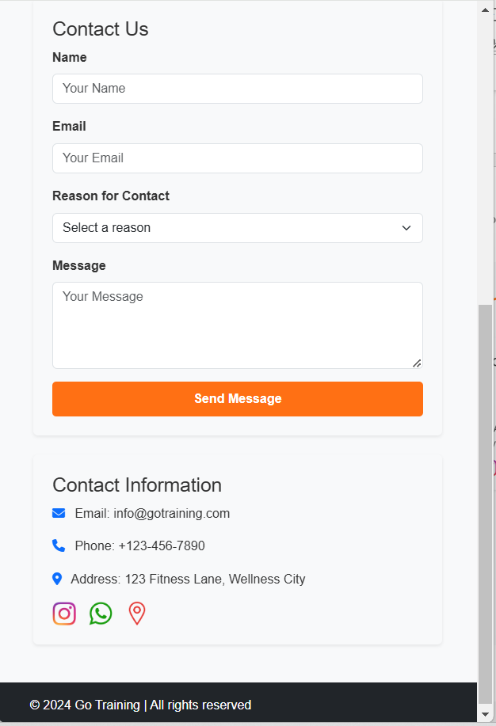

**Footer**:

The footer is simple and flexible, with centered text and padding. It will adapt to the screen width and display correctly on both mobile and desktop.



**Gym Page Nav Bar**

Just like on the previous page, the effects on the navbar were repeated here to maintain coherence in responsiveness and design.

**Carousel**:

The carousel uses **Bootstrap Carousel**, which is responsive by default. Images resize automatically using the classes d-block w-100.

The class carousel-caption d-none d-md-block hides the captions on screens smaller than "md" (≥768px), ensuring a cleaner interface.

**Result**:  
On small screens, the focus remains on images without overwhelming users with text.

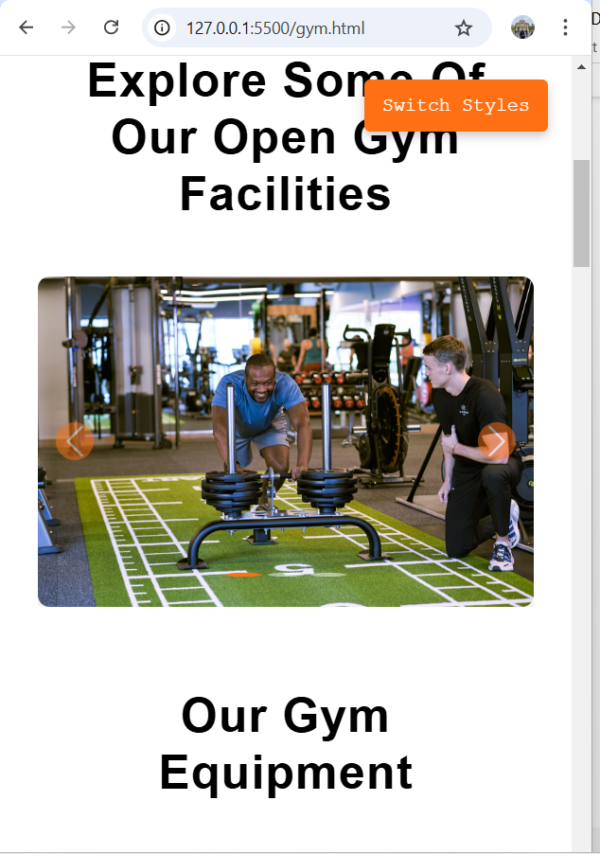

**Responsive Grid System**

The page uses Bootstrap’s **Grid System** to organize elements, such as equipment and trainers:

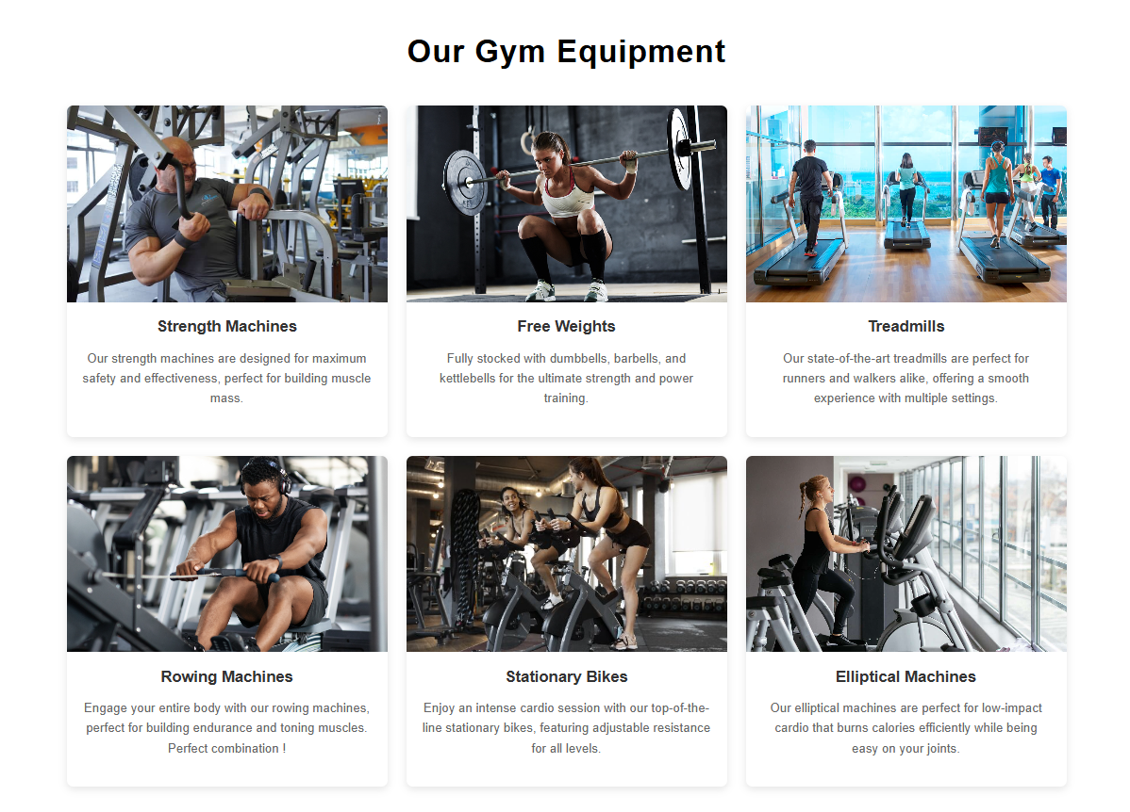

**Dynamic Style Switcher**

The "Switch Styles” button toggles between two CSS files (external.css and stylesAlex.css). This dynamic feature can change the appearance and potentially the responsiveness of the page if the styles differ significantly.

# Website Deployment

The website was deployed on GitHub Pages. Challenges included aligning the navigation bar across all pages, which was resolved through collaboration. Also, one of the pages had one image that, after deployment, did not open. So, we checked and it was a typing error which immediately was corrected.

Link to the website: <https://silveiraguilherme.github.io/gotrainingfitness/>

# 6. Results and Achievements

The “Go Training” website successfully met its objectives, offering a visually appealing and functional platform. Highlights include a fully responsive design, seamless navigation, and engaging interactive features.

# 7. Teamwork and Improvements

Collaboration among team members was effective, with clear task distribution and regular check-ins. Future improvements could include adding a backend for dynamic content and incorporating user feedback mechanisms.

# 8. Conclusion

The “Go Training Fitness Website” project provided valuable experience in web development, teamwork, and problem-solving. The final product is a testament to the team’s dedication to creating a high-quality, user-centered platform.

# 8. References

Bootstrap Documentation: <https://getbootstrap.com>

W3C Validator: <https://validator.w3.org>

Tinify (file compression): <https://tinypng.com>

Optimizilla (image compressor): https://imagecompressor.com/pt/

SmartFit: <https://www.smartfit.com.br/>

Bodytech: <https://www.bodytech.com.br/>

Competition Gym: <https://www.competition.com.br/>

BlueFit: <https://www.bluefit.com.br>